Run Command Prompt as Administrator.

To start this utility up, type **diskpart** and press enter.

To list the disk installed on the computer and their status type **list disk** and press enter

To change the status of a disk you’ll first need to select it and then change the status.

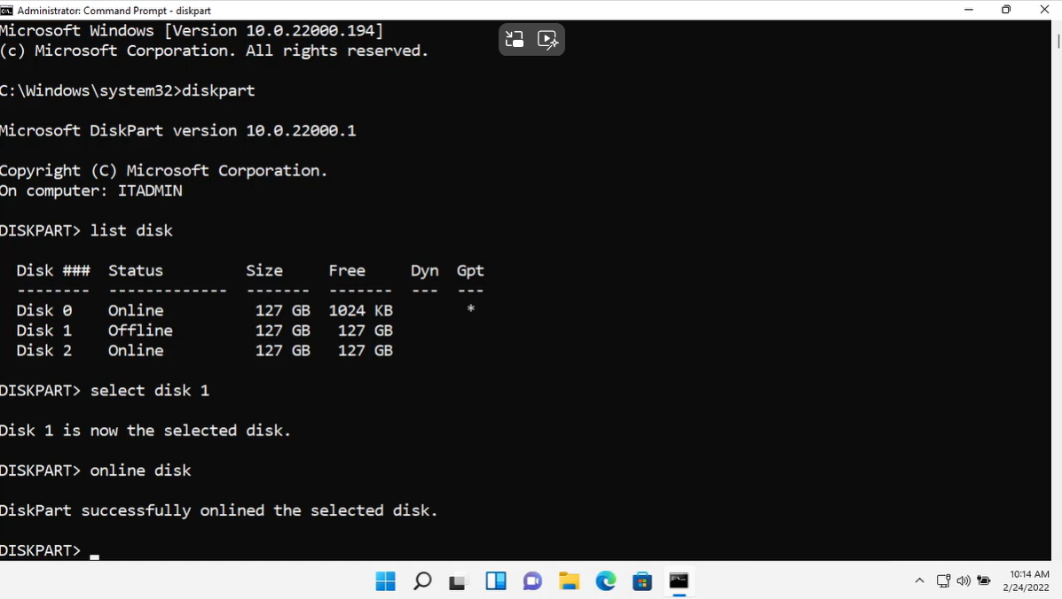

To convert a partition, you either enter **convert mbr** or **convert gpt**

To create a primary partition, you enter **create partition primary**

To format a partition, you’ll first **type list partition** to display the list of partition and then enter the following command: **format FS=NTFS (in this example) label=DATA (new volume name) quick**

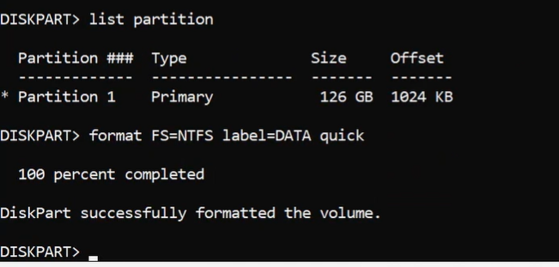

To assign a letter to the new volume enter the command **assign letter (Drive letter we choose)**

To create a primary partition and specify a sized, you enter **create partition primary size=number (63000 in this example)**

To format a partition for GPT File system, you’ll need to first select the partition and then use the format command.

To display the options available for the convert command type **convert /?**

To convert from FAT32 to NTFS, type **convert “partition assigned letter”: /fs:ntfs**

